## Question 1

Relational schema diagram:



## Question 2 <<Option>>

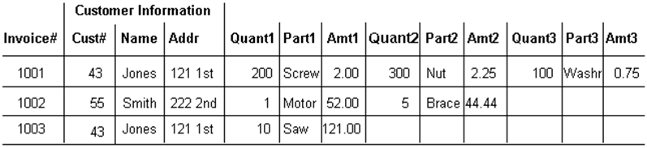

1. Normalize that table structure to the first, second and third normalization forms

* 1NF:
* INVOICE(INVOICE_ID,CUSTOMER_ID,CUSTOMER_NAME, CUSTOMER_ADDRESS)
* INVOICE_ITEM(INVOICE_ID,QUANT,PART,AMT)
* 2NF:
* INVOICE(INVOICE_ID,CUSTOMER_ID,CUSTOMER_NAME, CUSTOMER_ADDRESS)
* PRODUCT(PRODUCT_ID,PRODUCT_NAME,PRODUCT_PRICE)
* INVOICE_ITEM(INVOICE_ID,QUANT, PRODUCT_ID,AMT)
* 3NF:
* CUSTOMER(CUSTOMER_ID, CUSTOMER_NAME,CUSTOMER_ADDRESS)
* INVOICE(INVOICE_ID,CUSTOMER_ID)
* PRODUCT(PRODUCT_ID,PRODUCT_NAME,PRODUCT_PRICE)
* INVOICE_ITEM(INVOICE_ID,QUANT, PRODUCT_ID,AMT)

1. Relational schema diagram in the third normalization:

